**CHAPTER 4**

**DESIGN AND METHODOLOGY**

**4.1 Conceptual Framework**

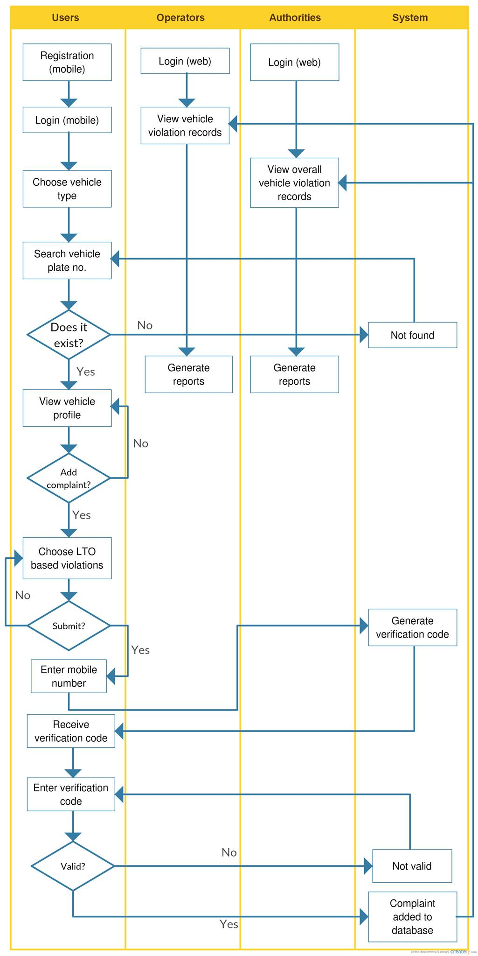

**Figure 1**- Swimlane Diagram for Public Vehicle Complaint Management System

**4.2 Analysis and Design**

**4.2.1 Use-Case Diagram**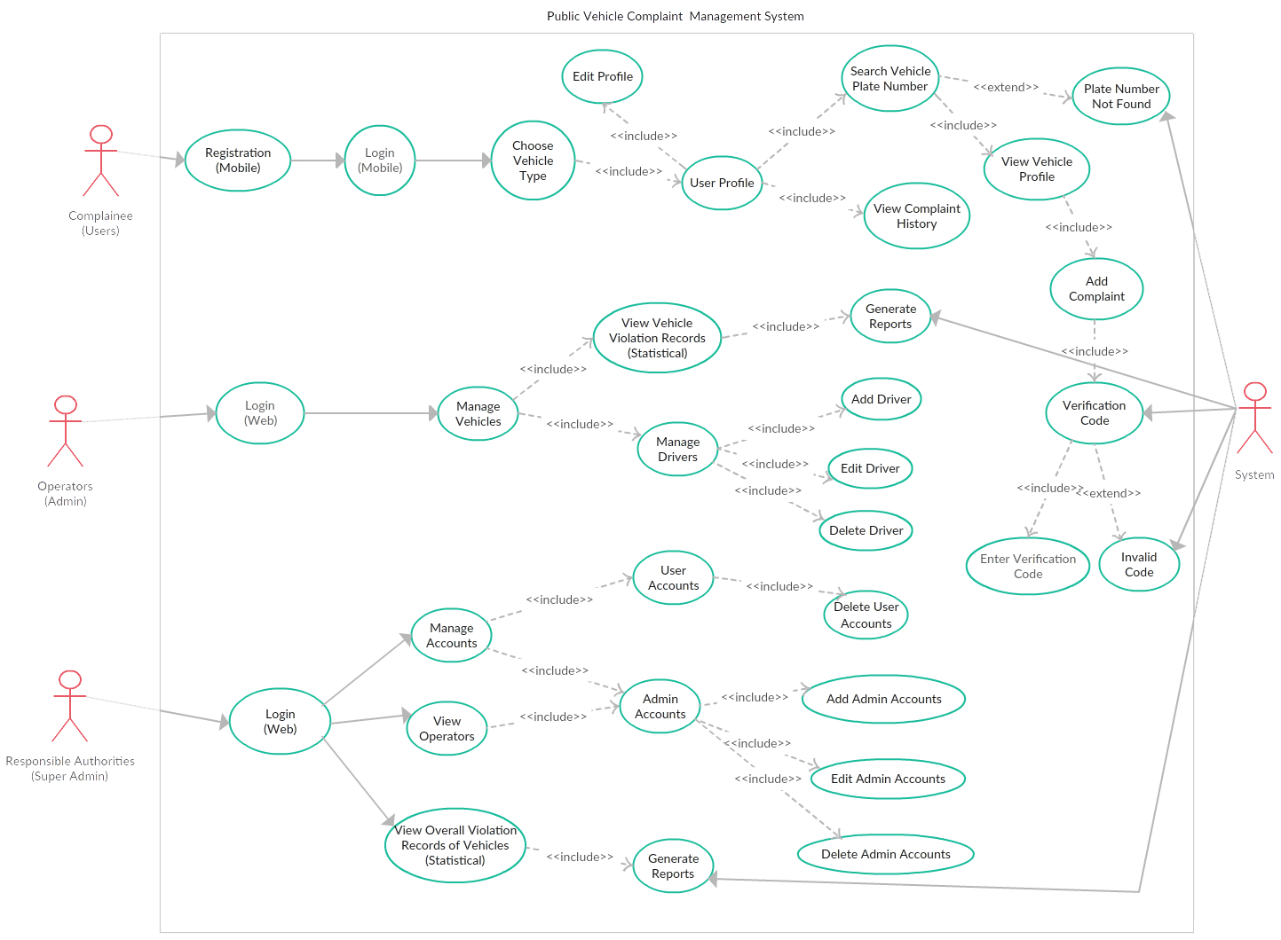

**Figure 2**- Use-Case Diagram for Public Vehicle Complaint Management System

**Table 1** - Use-Case List of Flows

|  |  |  |
| --- | --- | --- |
| **Use-Case Name** | **Description** | **Actor** |
| Registration(Mobile) | The users of the application will have to undergo registration in order to login to the system. | Commuters/Passengers/Fellow Drivers (Users) |
| Login(Mobile) | After registration, the users can log-in and can proceed further to the system. |
| Choose Vehicle Type | After login, the users need to choose a vehicle type for their complaint. |
| User Profile | After choosing vehicle type, the users will be directed to their profile. In which, they can edit profile, search vehicle plate number, and view their complaint history. In addition, their recent complaints will be displayed in their profile. |
| Edit Profile | The users can edit their profile. In which they can change their nickname, profile image, and password. |
| View Complaint History | The users can view their complaint history. It will display the driver details, the vehicle details and the violation details. |
| Search Vehicle Plate Number | The users can search a vehicle plate number for them to add their complaint to that vehicle. If the plate number has found the users will be directed to the vehicle profile. |
| Plate Number Not Found | If the plate number of the vehicle doesn’t exist the system will display “plate number not found” and will remain still in the Search Page. | System |
| View Vehicle Profile | If the searched plate number has been found by the system, the users can view the vehicle profile which displays the driver details, and vehicle details. | Commuters/Passengers/Fellow Drivers (Users) |
| Add Complaint | The users can add a complaint to the vehicle if it commits a traffic violation. The violations will be based on the LTO’s common violations. Then the system will ask for the phone number before they can submit the complaint. |
| Verification Code | Before the complaint will be submitted to the system, the system will send a verification code to the user’s phone number. | System |
| Enter Verification Code | After the system sent the verification code, the user will enter the verification code that is sent by the system. If the verification code is Valid then the complaint will be added to the system. | Commuters/Passengers/Fellow Drivers (Users) |
| Invalid Code | If the user has inputted an invalid code the system will display “Invalid Verification Code” and will remain still in the Verification Page. | System |
| Login(Web) | The operator needs to login based on the account that is given by the super admin. If the login is successful they can proceed further to the system. | Operators(admin) |
| Manage Vehicles | After logging in to the system, the admin can manage vehicles. In which they can view the vehicle violation records statistically, and manage drivers. |
| View Vehicle Violation Records (Statistical) | The admin can view the vehicle violation records for them to assess the vehicle drivers. They can also generate the records to a report if they want a hardcopy. |
| Generate Reports | The system will generate the records to a report and will make it to a PDF file that is printable. | System |
| Manage Drivers | The admin can manage the drivers in the vehicle. In which they can add a driver to that vehicle, edit the driver, and remove the driver. | Operator(admin) |
| Add Driver | The admin can add a driver to an empty vehicle. |  |
| Edit Driver | The admin can edit the driver details and update it. |
| Delete Driver | The admin can remove a driver, if the driver must be removed or the driver will leave the company. |
| Login(Web) | The super admin must first login to the system using the credentials given by the system or the modified credentials. Once the login is successful, the super admin can now continue to the system. | Responsible Authorities (Super Admin) |
| Manage Accounts | The super admin can manage the accounts of the user and admin accounts. |
| User Accounts | The super admin can view all the user accounts listed in the system. While viewing the super admin can choose to delete it. |
| Delete User Account | The super admin can delete the user account that has violated the terms and conditions. |
| Admin Accounts | The super admin can view all the admin accounts listed in the system. While viewing the super admin can manage it. |
| Add Admin Account | The super admin can add an admin account if there is an operator wants to register in the system. |
| Edit Admin Account | The super admin can edit an admin account if there are changes to the operator. |
| Delete Admin Account | The super admin can delete the operator account if they violate the terms and conditions or the operator has a purpose to be removed. |
| View Operators | The super admin can view the operators that are registered in the system. While viewing, the super admin can manage it. |
| View Overall Violation Records of Vehicles (Statistical) | The super admin can view the overall vehicle violation records for them to evaluate the operators. They can also generate the records to a report if they want a hardcopy and make it as an evidence. |
| Generate Reports | The system will generate the records to a report and will make it to a PDF file that is printable. | System |

**4.2.2 Entity Relationship Diagram**

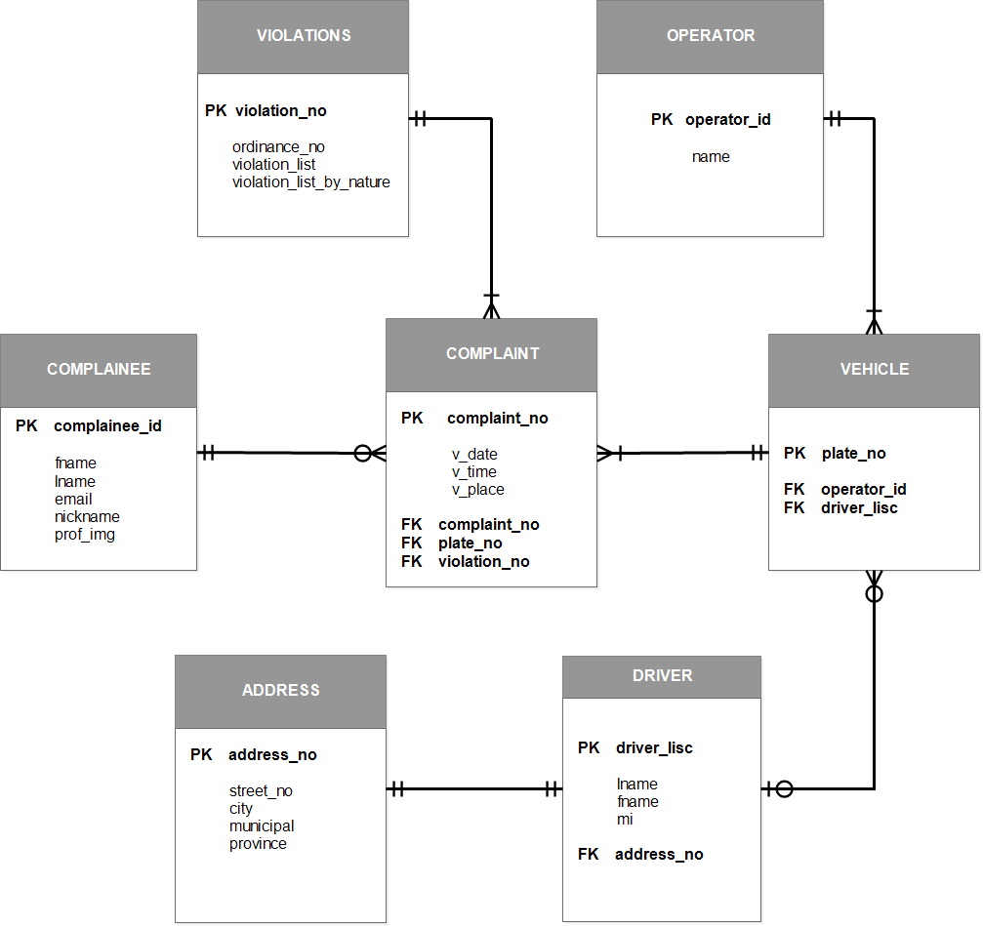

**Figure 3 –** *Entity Relationship Diagram for Public Vehicle Complaint Management System*